|  |  |
| --- | --- |
| **PROJECT** | COLLAR HEATING MACHINE |
| **WORK ORDER NO.** | WFAP22241 |
| **CUSTOMER** | BFL - MUNDHWA |
| **END USER** | BFL - MUNDHWA |
| **DAP DATE** | 12/07/2022 |
| **PLACE** | ONLINE |
| **ATTENDED BY(CUBIX)** | 1) MR. SANJAY BANKAR  2) MR. MILIND TAWALE    3) MR. SANDEEP DHIWAR |
| **ATTENDED BY CUSTOMER)** | 1) MR. RAHUL LALE  2) MR. NITIN KAMAT  3) |

**INDEX**

|  |  |  |  |  |
| --- | --- | --- | --- | --- |
| **SR.NO.** | **CONTENTS** | **PAGE NO.** | **APPROVAL** | **REMARK** |
|  | | | | |
| 1  1 | **SYSTEM LAYOUT** | 03 |  |  |
| 2 | **IO LIST** | 04-05 |  |  |
| 3 | **OPERATION SEQUENCE** | 06 |  |  |
| 4 | **ELECTRICAL ITEMS MAKE LIST** | 07 |  |  |
| 5 | **SCOPE OF SUPPLY** | 08 |  |  |
| 6 | **ELECTRICAL DRAWING** | 09- |  |  |

**1 – SYSTEM LAYOUT**

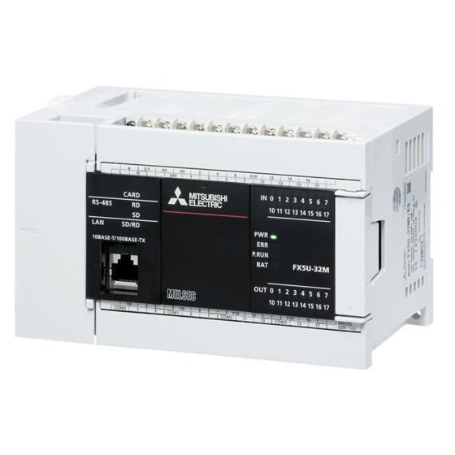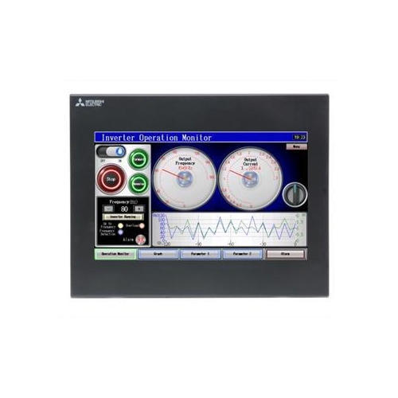

GS2107-WTBD

FX5U-32MR/ES

**2 – IO LIST**

|  |  |  |  |  |  |
| --- | --- | --- | --- | --- | --- |
| **COLLAR HEATING MACHINE** | | | | | |
| **DATE- 07.07.2022 REV. 1.0** | | | | | |
| **SR.NO.** | **PLC ADD.** | **DISCRIPTION** | **TYPE** | **COLOUR CODE** | **LOCATION** |
| **MAIN PLC FX5U-32M** | | | | | |
| 1 | X00 | EMERGENCY STOP | E STOP | RED | PANEL |
| 2 | X01 | AUTO/MANUAL | SELECTOR SWITCH | BLACK | PANEL |
| 3 | X02 | CYCLE START | PUSH BUTTON | GREEN | PANEL |
| 4 | X03 | CYCLE STOP | PUSH BUTTON | RED | PANEL |
| 5 | X04 | HEAT ON/OFF | SELECTOR SWITCH | BLACK | PANEL |
| 6 | X05 | SLIDE MECH. SOL.ON | SELECTOR SWITCH | BLACK | PANEL |
| 7 | X06 | TEMP. SENSOR SOL. ON | SELECTOR SWITCH | BLACK | PANEL |
| 8 | X07 | INV. READY | FEEDBACK | NA | PANEL |
| 9 | X10 | TEMPRETURE CONTROLLER | FEEDBACK | NA | PANEL |
| 10 | X11 | DWRS PUMP ON/OFF | SELECTOR SWITCH | BLACK | PANEL & FIELD |
| 11 | X12 | FAULT RESET | PUSH BUTTON | YELLOW | PANEL & FIELD |
| 12 | X13 | SPARE | SPARE | SPARE | SPARE |
| 13 | X14 | SPARE | SPARE | SPARE | SPARE |
| 14 | X15 | SPARE | SPARE | SPARE | SPARE |
| 15 | X16 | SPARE | SPARE | SPARE | SPARE |
| 16 | X17 | SPARE | SPARE | SPARE | SPARE |

|  |  |  |  |  |  |
| --- | --- | --- | --- | --- | --- |
| **COLLAR HEATING MACHINE** | | | | | |
| **DATE- 07.07.2022 REV. 1.0** | | | | | |
| **SR.NO.** | **PLC ADD.** | **DISCRIPTION** | **TYPE** | **COLOUR CODE** | **LOCATION** |
| **MAIN PLC FX5U-32M** | | | | | |
| 1 | Y00 | HEAT ON | RELAY | NA | PANEL (POT FREE) |
| 2 | Y01 | SLIDE MECH. SOL.ON | RELAY | NA | PANEL |
| 3 | Y02 | TEMP. SENSOR SOL. ON | RELAY | NA | PANEL |
| 4 | Y03 | SPARE | SPARE | SPARE | SPARE |
| 5 | Y04 | SPARE | SPARE | SPARE | SPARE |
| 6 | Y05 | SPARE | SPARE | SPARE | SPARE |
| 7 | Y06 | SPARE | SPARE | SPARE | SPARE |
| 8 | Y07 | SPARE | SPARE | SPARE | SPARE |
| 9 | Y10 | SPARE | SPARE | SPARE | SPARE |
| 10 | Y11 | SPARE | SPARE | SPARE | SPARE |
| 11 | Y12 | SPARE | SPARE | SPARE | SPARE |
| 12 | Y13 | SPARE | SPARE | SPARE | SPARE |
| 13 | Y14 | SPARE | SPARE | SPARE | SPARE |
| 14 | Y15 | SPARE | SPARE | SPARE | SPARE |
| 15 | Y16 | SPARE | SPARE | SPARE | SPARE |
| 16 | Y17 | SPARE | SPARE | SPARE | SPARE |

**3 – OPERATION SEQUENCE**

**3.1 – MANUAL MODE**

Manual Mode is for function check purpose. Operator can use manual mode for job adjustment and setting. Selector Switch should be on Manual.

1. Coil Up/Down - Coil Up/Down Operation can be performed by selector switch provided.

**3.2 AUTO MODE**

Home condition

* Emergency Healthy
* Auto mode selected
* coil cyl. Output off
* Job Present

Auto Operation

Step 1 – If Home Condition ok, Operator presses ‘Test Start ‘push button.

Step 2 – Coil Cylinder (Single Acting pneumatic cylinder) output gets on, coil gets down. This output remains on till cycle complete.

Step 3 – ‘Heat On’ Output will get on which switch on the potential free relay on.

This output on- off function is depend upon ‘with heat /without heat ‘selector switch.

With heat – ‘Heat On ‘output will get on.

Without heat – ‘Heat On ‘output will remain off.

Step 4 – Pre-settable timer(seconds) will start. Time Can be settable from HMI.

Step 5 – After Timer Complete ‘Heat On ‘and ‘Coil Up/Down’ output will get off.

Step 6 – Cycle Complete.

Step 7 – While Cycle is running and operator presses ‘Test Stop’ push button, step 5 gets executed.

Step 8 – If Cycle is running and operator presses ‘Emergency’ push button, step 5 gets executed.

**4 – PART MAKE LIST**

|  |  |  |
| --- | --- | --- |
| **Part Make List** | | |
| **Sr. No.** | **Part** | **Make** |
| 1 | PLC | Mitsubishi |
| 2 | HMI | Mitsubishi |
| 3 | MCB | Mitsubishi |
| 4 | SMPS | Omron |
| 5 | Relay Board | Standard |
| 6 | Terminals | Phoenix |
| 7 | Control Cable for Inside Panel Wiring | Lapp |
| 8 | Control Panel | Eldon |
| 9 | E Stop,Lamp, Selector Switch & Push Buttons | Teknic |
| 10 | Mains On Off Switch | Salzer |
| 11 | Transformer | Chintamani |
| 12 | Utility Socket | Anchor |
| 13 | Tube Light 11 Watt | Hawells/Philips |

**5 – SCOPE OF SUPPLY**

|  |  |  |  |
| --- | --- | --- | --- |
| **SR.NO.** | **ACTIVITY DESCRIPTION** | **SCOPE UNDER** | **REMARK** |
|  | | | |
| 1 | FA hardware | Cubix |  |
| 2 | PLC program | Cubix |  |
| 3 | HMI program | Cubix |  |
| 4 | SCADA development | NA |  |
| 5 | Control panel | Cubix |  |
| 6 | Packing Charges Scope and Type | NA |  |
| 7 | Forwarding Charges Scope | NA |  |
| 8 | Freight Scope | NA |  |
| 9 | Transit Insurance Scope | NA |  |
| 10 | Loading Scope | Cubix |  |
| 11 | Unloading Scope | BFL |  |
| 12 | Electrical drawing | Cubix |  |
| 13 | Field wiring materials | BFL |  |
| 14 | Field wiring labour/work | BFL |  |
| 15 | Field instruments | NA |  |
| 16 | Removal of old panel | BFL |  |
| 17 | Removal of old field wiring | BFL |  |
| 18 | Installation & commissioning | BFL & Cubix |  |
| 19 | Operator Training | Cubix |  |
| 20 | Panel Shifting | BFL |  |
| 21 | Lodging facility scope | NA |  |
| 22 | Boarding scope | NA |  |
| 23 | Travelling (To & From) scope | NA |  |
| 24 | Meal Arrangements at site-Scope | NA |  |
| 25 | Scope supply is restricted to material mentioned in quotation | | |
| 26 | Sensor, actuator, encoders, transmitters, connectors, adapters, printer are not considered. | | |
| 27 | Any civil / mechanical work at site not considered | | |
| 28 | Accuracy of system is up to electronic control only & does not involve any mechanical consultation or adjustments. | | |
| 29 | Any change in configuration will affect price. | | |
| 30 | Unless otherwise mentioned, Field cabling and cables mounting, fixing of PLC’s panels not included. | | |
| 31 | Unless otherwise mentioned, control panel & incoming power cable is not included in the scope of supply. | | |
| 32 | Consumables such as Ferrules, Lugs, labels are available at additional price | | |
| 33 | Communication cables and Software can be supplied at an additional Price and Online training can be offered free   by CAPL training division. | | |
| 34 | CAPL team continuously updates with latest technologies and assures free Online support by Service team on products supplied. | | |

**6 – ELECTRICAL DRAWING**